# Deep learning paper summary

A machine learning technique for MRI brain image:

A machine learning technique for MRI brain images,   
Heba Mohsen , El-Sayed Ahmed El-Dahshan, Abdel-Badeeh M. Salem , https://www.researchgate.net/publication/261468801_A_machine_learning_technique_for_MRI_brain_images

This study presents a proposed hybrid

intelligent machine learning technique for

Computer–Aided detection system for automatic detection

of brain tumor through magnetic resonance images. The

technique is based on the following computational

methods; the feedback pulse-coupled neural network for

image segmentation, the discrete wavelet transform for

features extraction, the principal component analysis for

reducing the dimensionality of the wavelet coefficients, and

the feed forward backpropagation neural network to

classify inputs into normal or abnormal. The experiments

were carried out on 101 images consisting of 14 normal

and 87 abnormal (malignant and benign tumors) from a real

human brain MRI dataset. The classification accuracy on

both training and test images is 99 % which was

significantly good.

This study presents a proposed hybrid

intelligent machine learning technique for

Computer–Aided detection system for automatic detection

of brain tumor through magnetic resonance images. The

technique is based on the following computational

methods; the feedback pulse-coupled neural network for

image segmentation, the discrete wavelet transform for

features extraction, the principal component analysis for

reducing the dimensionality of the wavelet coefficients, and

the feed forward backpropagation neural network to

classify inputs into normal or abnormal. The experiments

were carried out on 101 images consisting of 14 normal

and 87 abnormal (malignant and benign tumors) from a real

human brain MRI dataset. The classification accuracy on

both training and test images is 99 % which was

significantly good.

Abstract- This study presents a proposed hybrid

intelligent machine learning technique for

Computer–Aided detection system for automatic detection

of brain tumor through magnetic resonance images. The

technique is based on the following computational

methods; the feedback pulse-coupled neural network for

image segmentation, the discrete wavelet transform for

features extraction, the principal component analysis for

reducing the dimensionality of the wavelet coefficients, and

the feed forward backpropagation neural network to

classify inputs into normal or abnormal. The experiments

were carried out on 101 images consisting of 14 normal

and 87 abnormal (malignant and benign tumors) from a real

human brain MRI dataset. The classification accuracy on

both training and test images is 99 % which was

significantly good. Moreover

This study presents intelligent machine learning Computer–Aided detection system for automatic detection of brain tumor through magnetic resonance images. The technique is based on the following computational methods; the feedback pulse-coupled neural network for image segmentation, the discrete wavelet transforms for features extraction, the principal component analysis for reducing the dimensionality of the wavelet coefficients, and the feed forward backpropagation neural network to classify inputs into normal or abnormal. The experiments were carried out on 101 images consisting of 14 normal and 87 abnormal (malignant and benign tumors) from a real human brain MRI dataset. The classification accuracy on both training and test images is 99 % which was significantly good.

A schema of the architecture used:

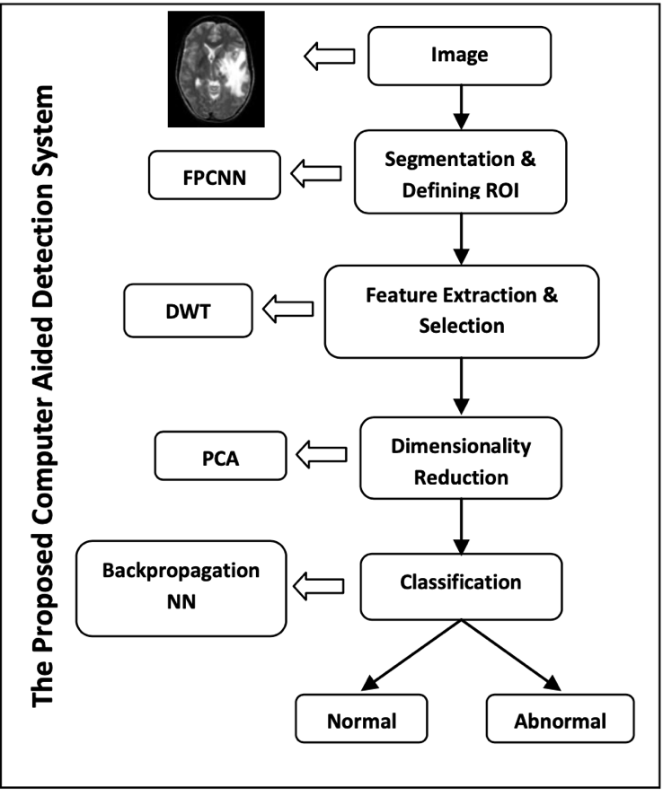

Brain Biomarker Interpretation in ASD Using Deep Learning and fMRI

Brain Biomarker Interpretation in ASD Using Deep Learning and fMRI, Xiaoxiao Li⋆, Nicha C. Dvornek†, Juntang Zhuang⋆, Pamela Ventola‡ and James S. Duncan, <https://arxiv.org/abs/1808.08296>

In This study, they address the problem of interpreting reliable biomarkers associated with identifying ASD; specifically, they propose a 2-stage method that classifies ASD and control subjects using fMRI images and interprets the saliency features activated by the classifier. First, they trained an accurate DNN classifier. Then, for detecting the biomarkers, different from the DNN visualization works in computer vision, they take advantage of the anatomical structure of brain fMRI and develop a frequency-normalized sampling method to corrupt images. Furthermore, in the ASD vs. control subjects classification scenario, they provide a new approach to detect and characterize important brain features into three categories.

Their method was designed for interpreting important ROIs for registered images, since the traditional machine learning feature selection methods can not be directly used in interpreting DNNs

Deep Learning for Neuroimaging-based Diagnosis and Rehabilitation of Autism Spectrum Disorder: A Review

Deep Learning for Neuroimaging-based Diagnosis and Rehabilitation of Autism Spectrum Disorder: A Review , Marjane Khodatars, Afshin Shoeibi, Navid Ghassemi, Mahboobeh Jafari, Ali Khadem, Delaram Sadeghi, <https://arxiv.org/pdf/2007.01285.pdf>

In this paper, studies conducted with the aid of deep learning networks to distinguish ASD were investigated. Rehabilitation tools provided by supporting ASD patients utilizing DL networks were also assessed. Finally, we presented important challenges in the automated detection and rehabilitation of ASD.

There are exploring the use of a CAD system using DL architecture on the ABIDE data set.

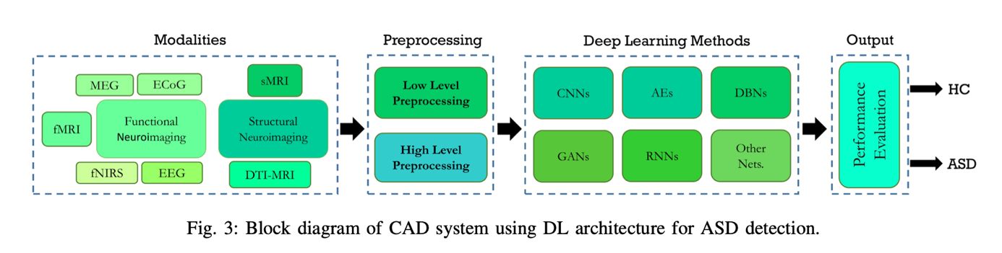

They performed a comprehensive overview of the investigations conducted in the scope of ASD diagnostic CAD systems as well as DL-based rehabilitation tools for ASD patients. In the field of ASD diagnosis, numerous papers have been published using functional and structural neuroimaging data as well as rehabilitation tools, as summarized in the table in the paper.